GLOBAL CO2 EMISSION ANALYSIS

**INTRODUCTION**

**OVERVIEW:**

Carbon dioxide (CO2) is released into Earth’s atmosphere mostly by the burning of carbon-containing fuels and the decay of wood and other plant matter. The amount of CO2 in the atmosphere has increased greatly since human beings began burning large amounts of coal and petroleum in the nineteenth century.

In more recent times, this source of CO2 emissions has increased rapidly, while destruction of forests has also become a major source of CO2. Atmospheric concentrations of several other gases, including methane and nitrous oxide , have also been increased recently by human activities and are contributing to greenhouse warming of the planet. Global warming is one of the biggest challenges currently being faced by the human race.

For this analysis we will be focusing on CO2 Emissions and its effect on the world we live in as well as some key factors and stats that may play a role in the emission of CO2 globally. This will help researchers and environment experts to predict global warming. So countries should set a goal to decrease this amount yearly.

**PURPOSE:**

The goal is to aware the world about CO2 emission globally. The purpose of analyzing CO2 emissions globally is to understand the scale and impact of human activities on the environment, particularly the effects of burning fossil fuels on the earth's climate.

CO2 is a greenhouse gas that traps heat in the atmosphere, leading to global warming and climate change. As a result, measuring and analyzing CO2 emissions can provide insights into the causes and consequences of climate change, as well as inform policy decisions aimed at reducing greenhouse gas emissions and mitigating the effects of climate change.

By understanding the sources and trends of CO2 emissions globally, we can take steps to reduce our carbon footprint and work towards a more sustainable future.

**PROBLEM DEFINING & DESIGN THINKING**

**EMPATHY MAP**

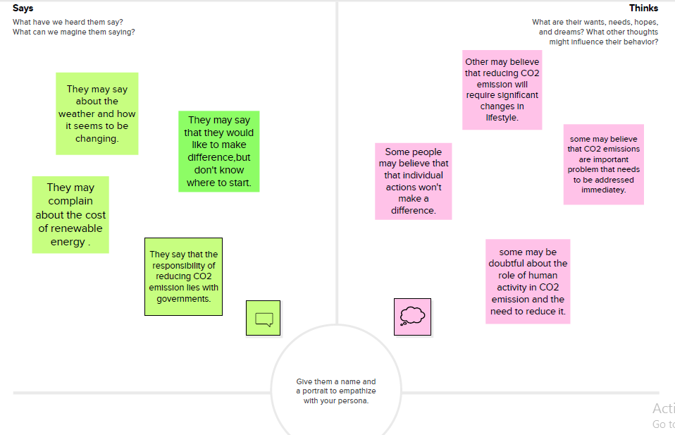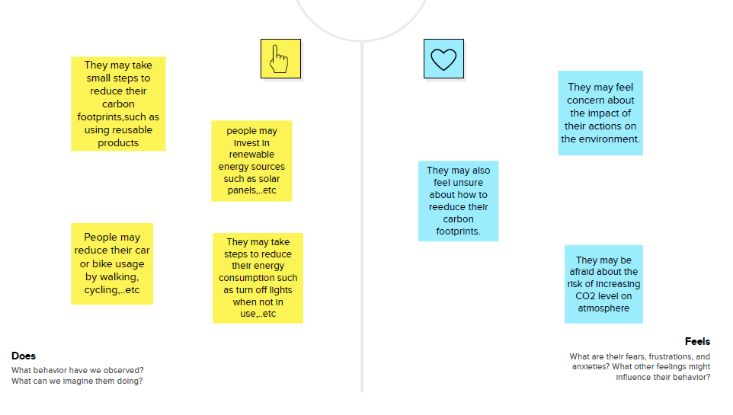**IDEATION & BRAINSTORMING MAP**

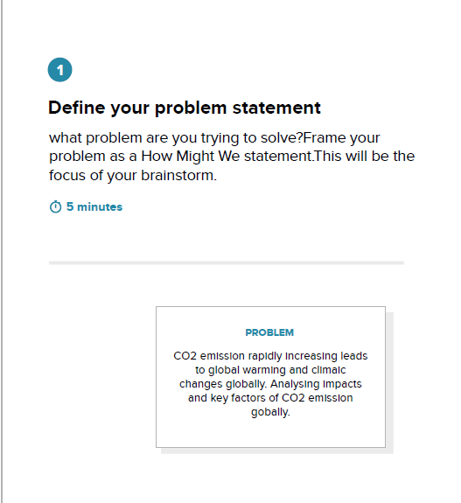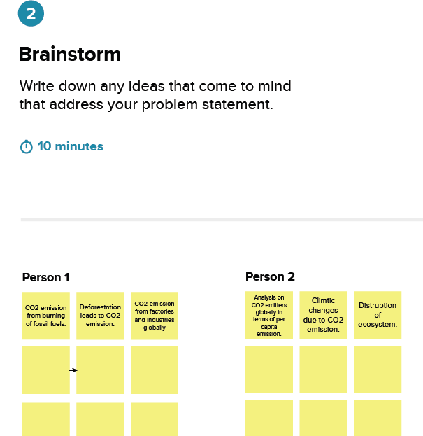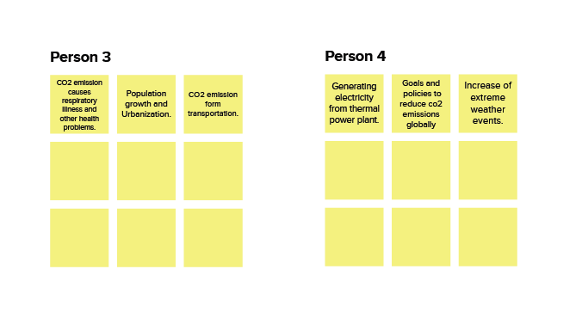**GROUP IDEAS** 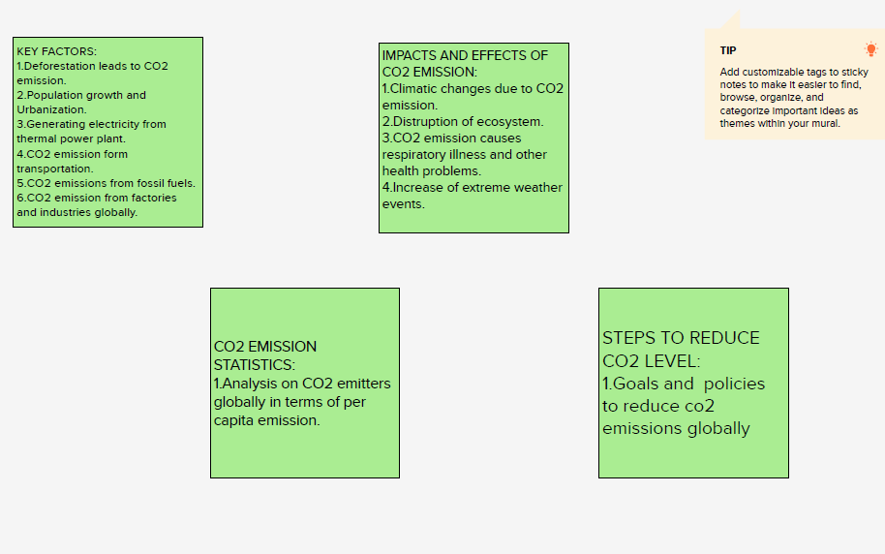

**IDEA PRIORITIZATION**

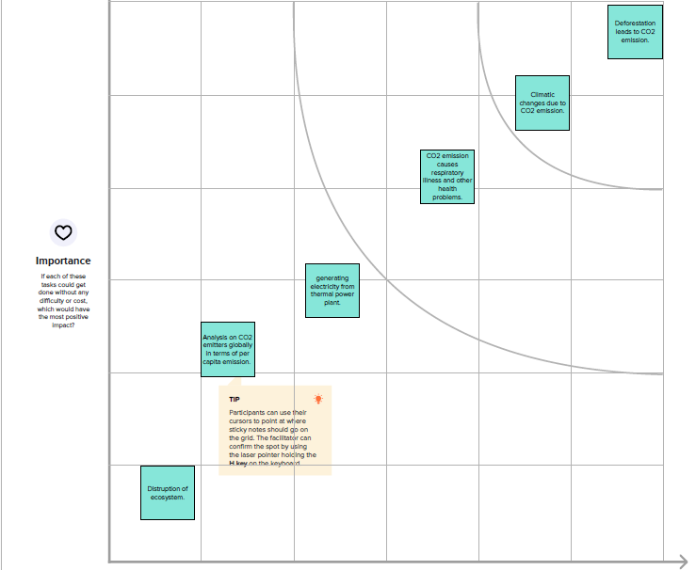

**RESULTS**

**[Final output of the project - Dashboard, Story & Web application]**

**DASHBOARD 1**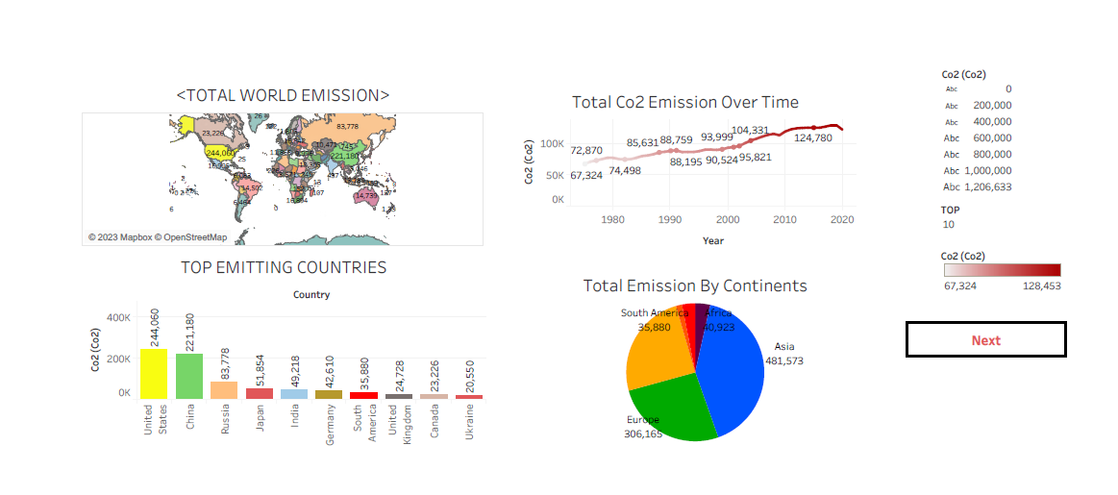

**DASHBOARD2**

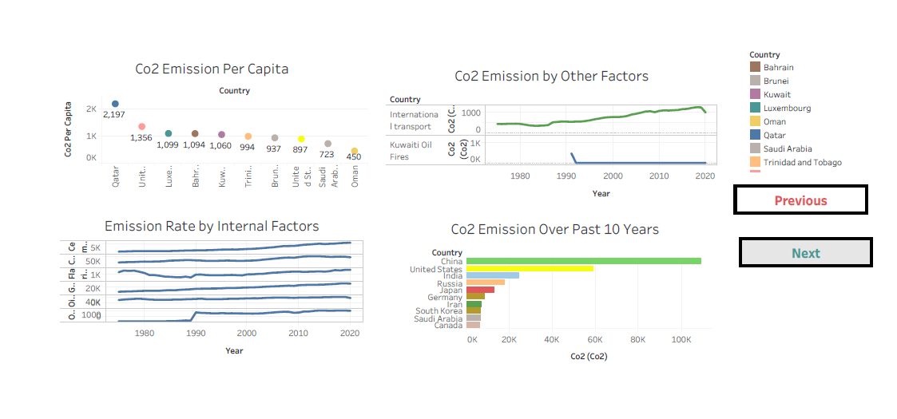**DASHBOARD3**

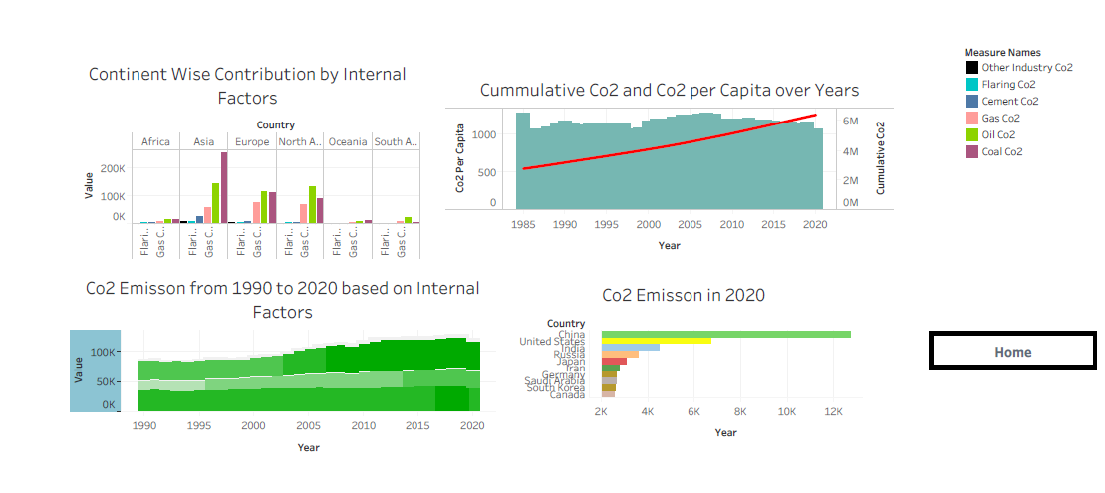**STORY**

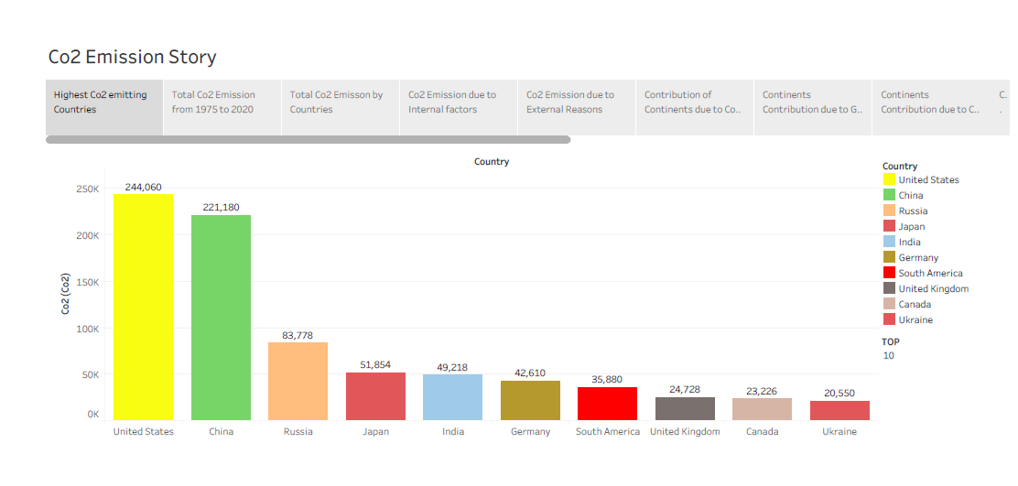

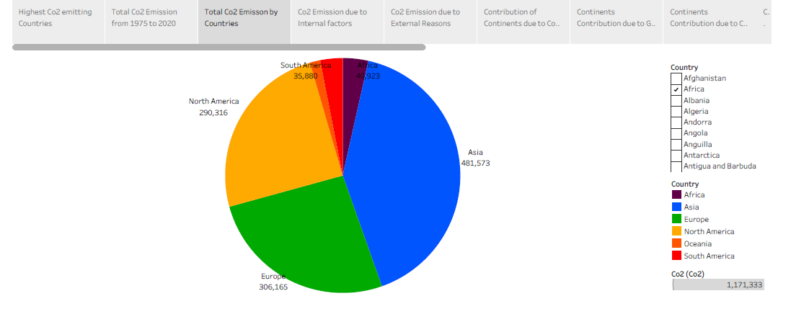

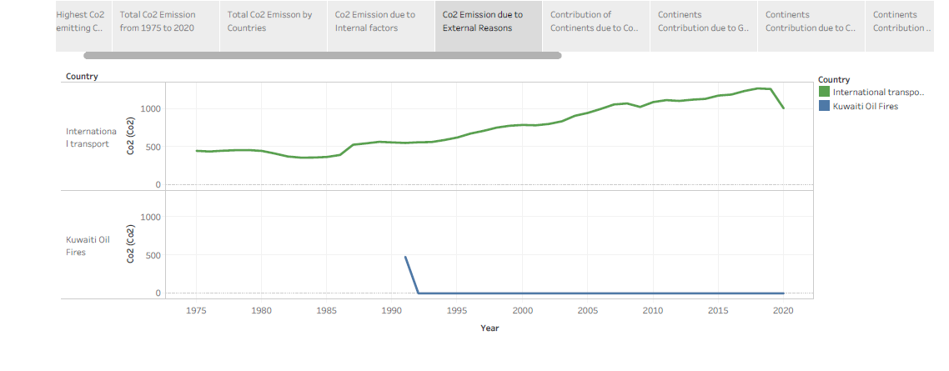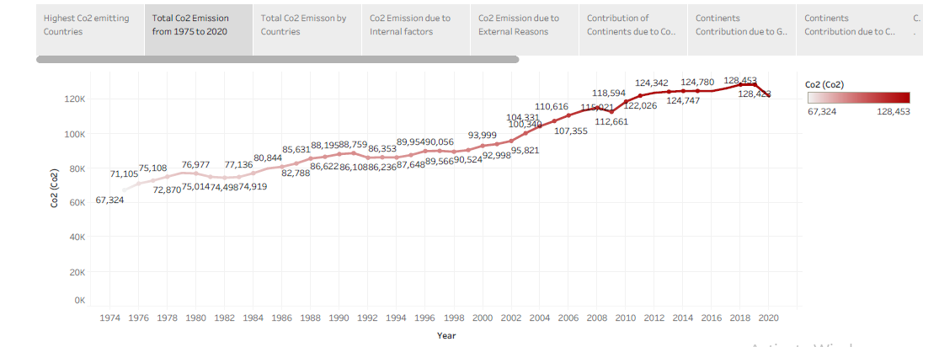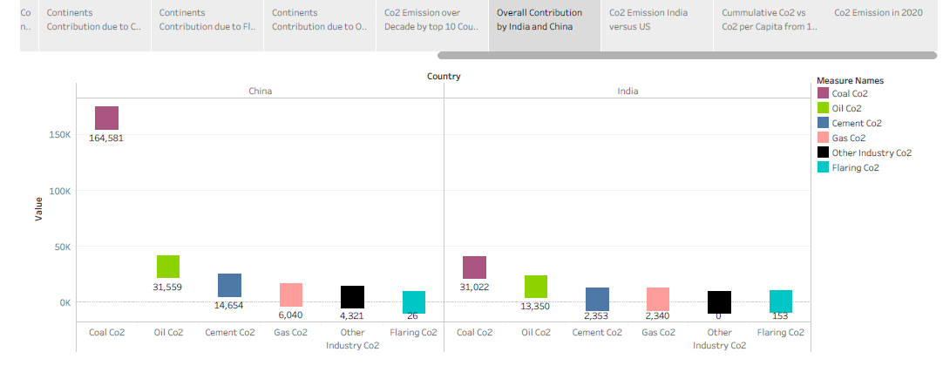

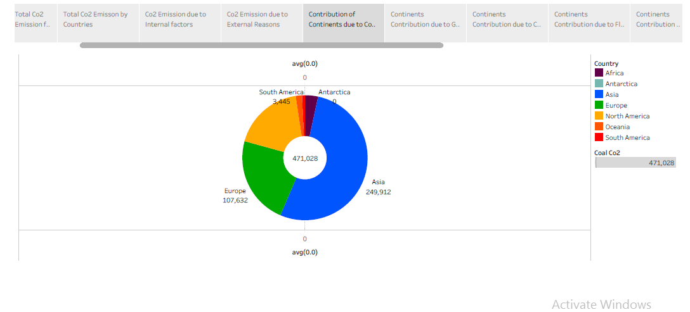

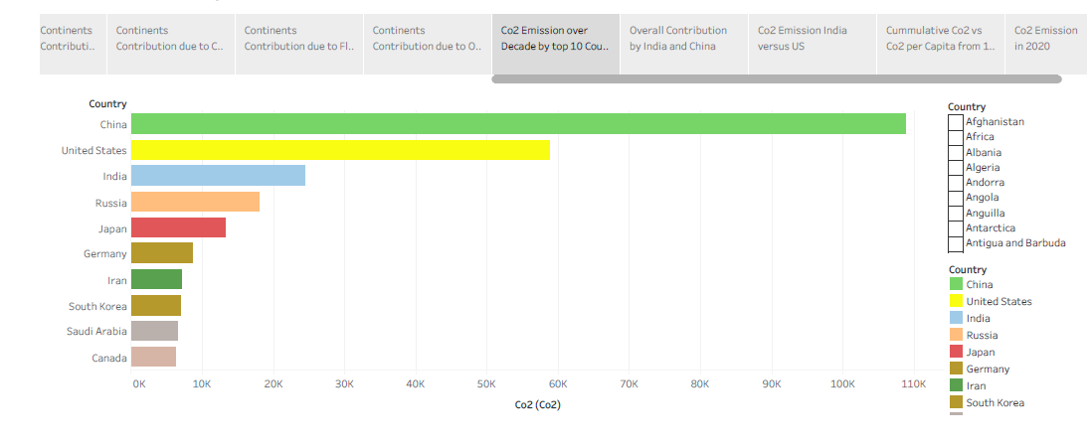

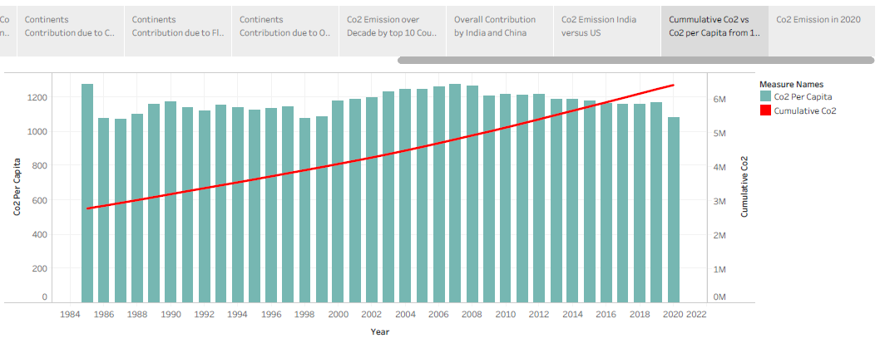

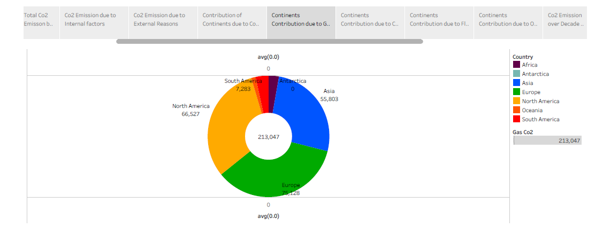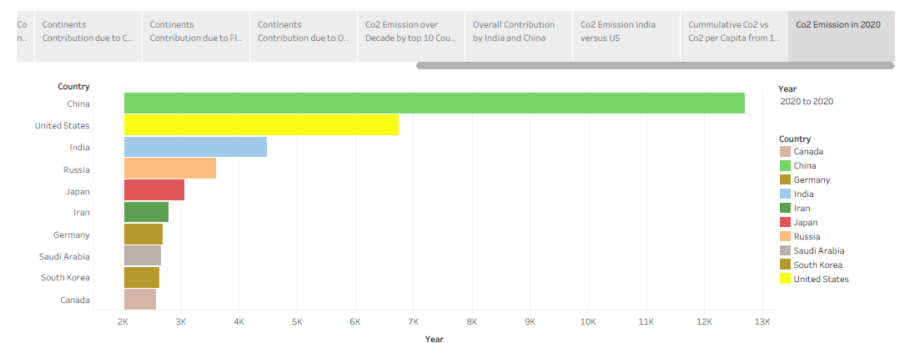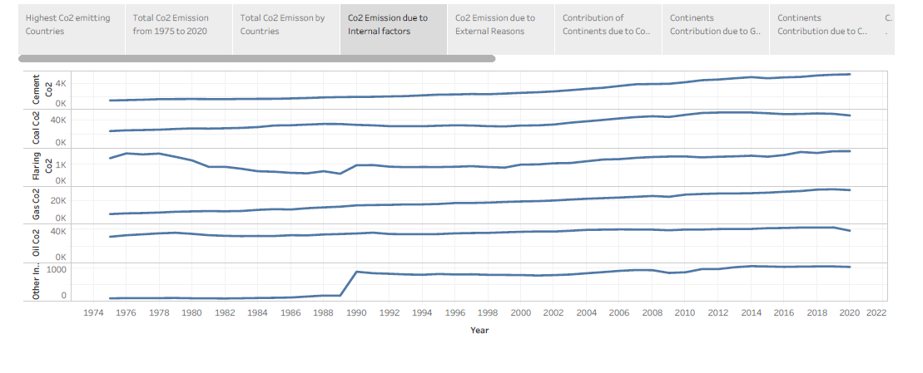

**WEB APPLICATIONS**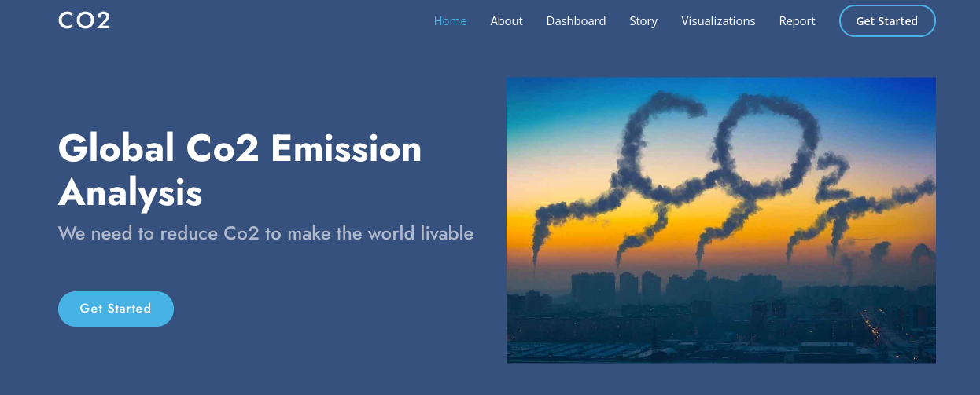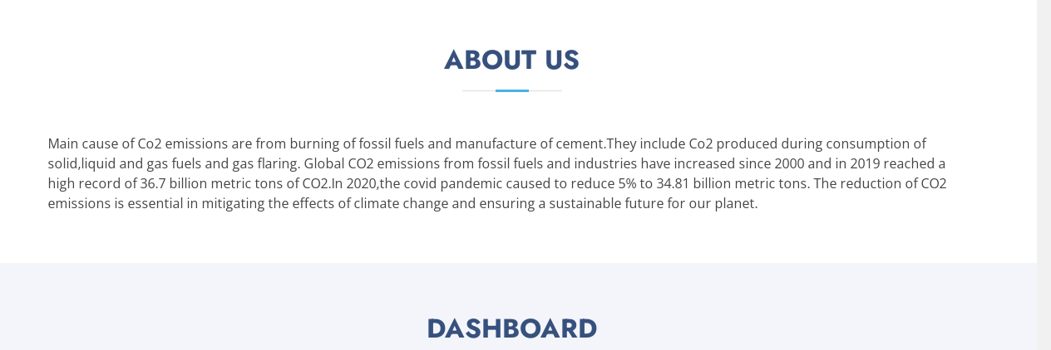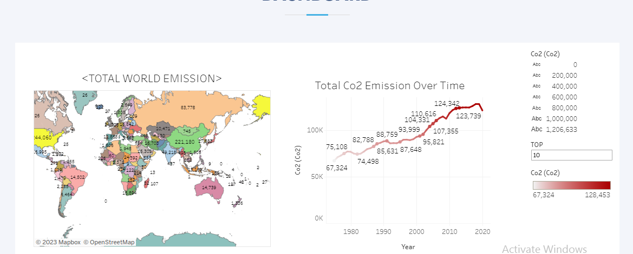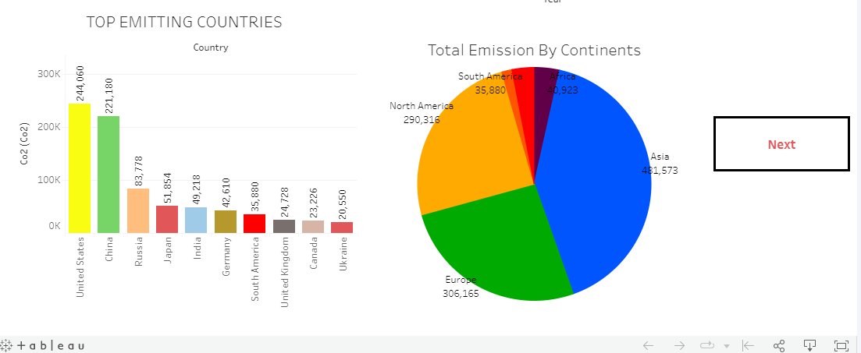

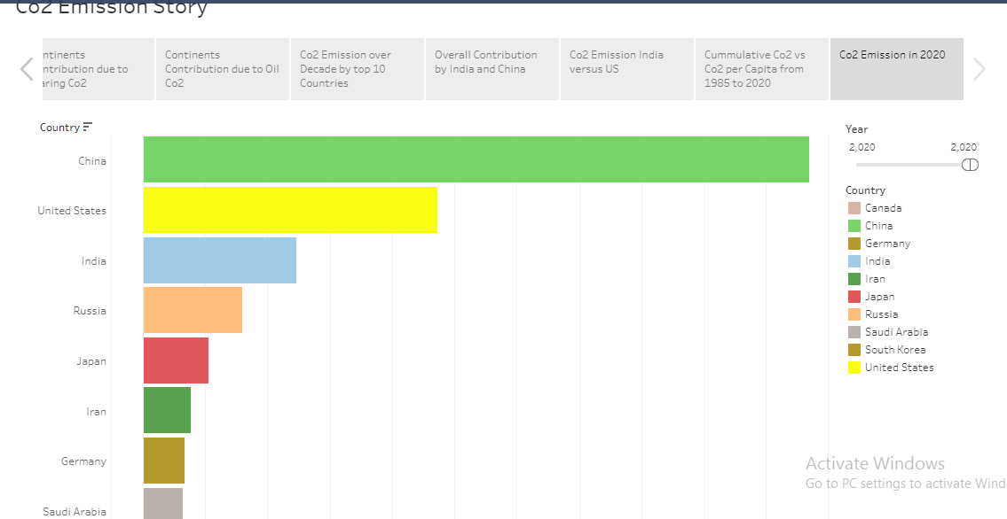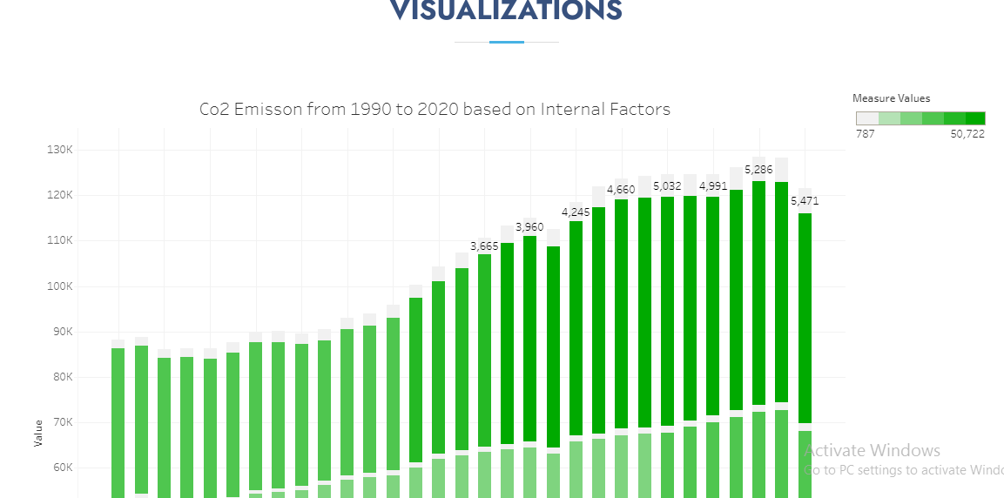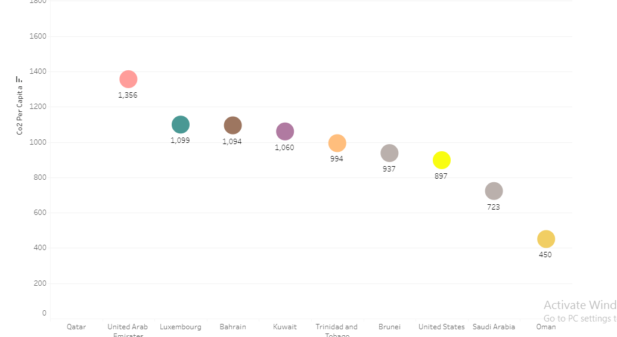

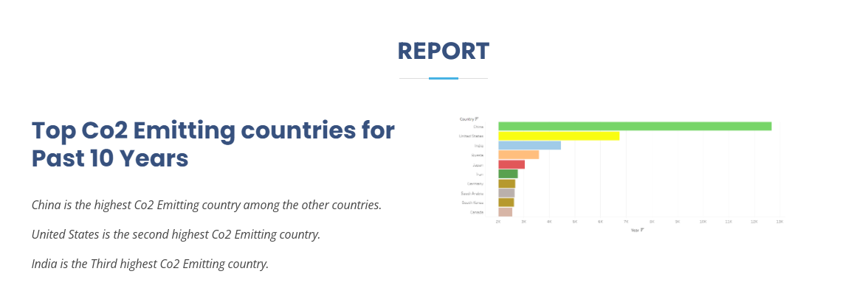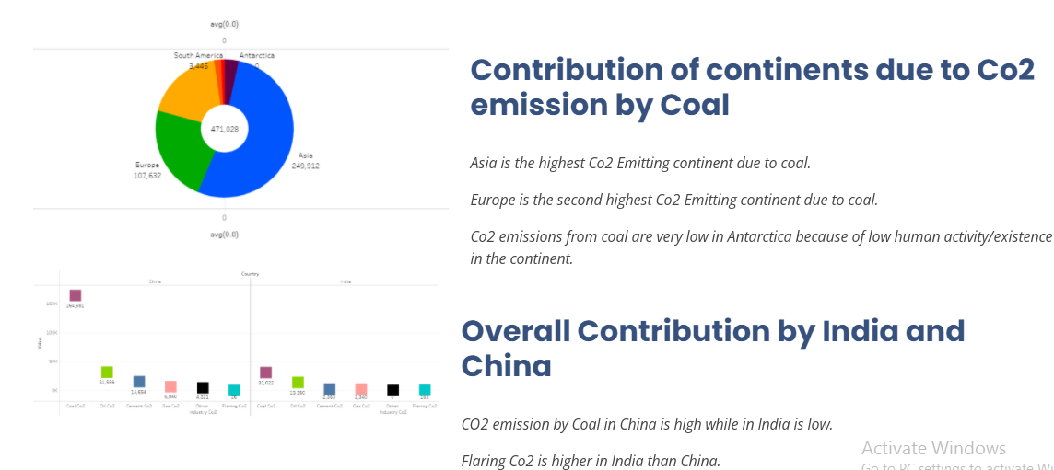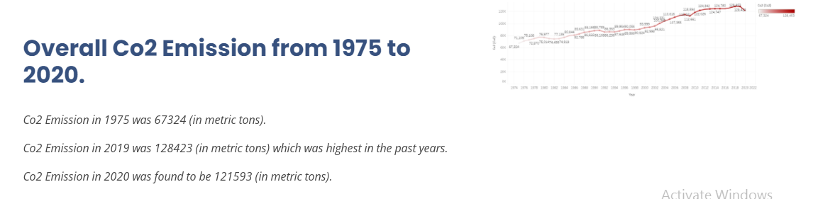

**ADVANTAGES OF PROPOSED SOLUTION**

1. **Environmental Benefits**: Analyzing CO2 emissions helps in identifying the sources of emissions and taking appropriate measures to reduce them. This can lead to significant environmental benefits by reducing greenhouse gas emissions, which contribute to climate change and global warming.
2. **Energy Efficiency:** By analyzing CO2 emissions, we can identify areas of energy inefficiency and take steps to improve them. This can lead to significant energy savings and lower operating costs for businesses and households.
3. **Regulatory Compliance:** Many countries have regulations that require businesses to report their CO2 emissions. By analyzing emissions data, companies can ensure they are in compliance with these regulations and avoid penalties.
4. **Competitive Advantage**: Analyzing CO2 emissions can help businesses identify opportunities to reduce costs and improve their environmental performance. This can give them a competitive advantage in the marketplace by demonstrating their commitment to sustainability and attracting environmentally conscious consumers.
5. **Public Relations:** Analyzing CO2 emissions and taking steps to reduce them can improve a company's public image and reputation. This can lead to increased brand loyalty and customer trust.

Overall, analyzing CO2 emissions can provide a range of benefits for businesses, governments, and society as a whole.

**DISADVANTAGES**

1. **Cost:** Analyzing CO2 emissions can be expensive, particularly for smaller businesses and organizations. The cost of monitoring and reporting emissions can be significant, and there may be additional costs associated with implementing measures to reduce emissions.
2. **Complexity:** The process of analyzing CO2 emissions can be complex and time-consuming. It may require specialized knowledge and expertise, and there may be challenges in collecting accurate and reliable data.
3. **Limited Impact:** While analyzing CO2 emissions can help identify areas for improvement, it may not necessarily result in significant emissions reductions. For example, some businesses may struggle to find cost-effective ways to reduce their emissions without negatively impacting their operations.
4. **Data Privacy**: Collecting and reporting emissions data may raise concerns about data privacy and confidentiality. Companies may need to take steps to protect sensitive information and ensure that it is not misused or accessed by unauthorized parties.
5. **Regulatory Burden**: While regulations requiring emissions reporting can help to drive emissions reductions, they can also create a burden for businesses. Compliance can be time-consuming and costly, and there may be challenges in staying up to date with changing regulations.

Overall, while analyzing CO2 emissions can provide important insights and drive positive change, there are also potential challenges and drawbacks to consider.

**APPLICATIONS**

1. **Predictive Modeling**: Data analytics can be used to build predictive models that can forecast future CO2 emissions based on historical data. These models can help policymakers and businesses to plan and implement emission reduction strategies.
2. **Pattern Recognition:** Data analytics can be used to identify patterns and trends in CO2 emissions data. These insights can be used to identify areas for improvement, such as high-emitting industries or geographical areas with high emissions.
3. **Anomaly Detection**: Data analytics can be used to identify anomalies in CO2 emissions data. This can help identify issues such as malfunctioning equipment or inaccurate reporting, which can be corrected to reduce emissions.
4. **Benchmarking**: Data analytics can be used to benchmark CO2 emissions data against industry standards or peer organizations. This can help identify areas for improvement and set targets for emissions reductions.
5. **Optimization**: Data analytics can be used to optimize emissions reduction strategies by analyzing data on emissions, energy use, and other factors. This can help identify the most effective strategies for reducing emissions while minimizing costs.
6. **Transportation**: Transportation is a major source of CO2 emissions, with cars, trucks, and other vehicles contributing a significant amount of greenhouse gas emissions. CO2 emission analysis can help identify areas for improvement, such as increasing the use of electric vehicles, improving fuel efficiency, and reducing congestion.
7. **Energy Production**: Energy production is another major source of CO2 emissions, with power plants and other facilities contributing a significant amount of greenhouse gas emissions. CO2 emission analysis can help identify ways to reduce emissions, such as increasing the use of renewable energy sources, improving energy efficiency, and implementing carbon capture and storage technologies.
8. **Manufacturing:** Manufacturing processes can also contribute to CO2 emissions, particularly in heavy industries such as steel and cement production. CO2 emission analysis can help identify areas for improvement, such as reducing energy use, improving process efficiency, and implementing carbon capture and storage technologies

Overall, CO2 emission analysis in data analytics can provide valuable insights into emissions data, helping to identify areas for improvement and optimize emissions reduction strategies.

**CONCLUSION**

In conclusion, CO2 emission analysis is an important tool for identifying sources of greenhouse gas emissions and developing strategies to reduce them. By analyzing CO2 emissions data, policymakers and businesses can identify areas for improvement, set targets for emissions reductions, and optimize strategies for reducing emissions. This can lead to significant environmental benefits, such as reducing greenhouse gas emissions and mitigating climate change. Additionally, analyzing CO2 emissions can provide other benefits such as improved energy efficiency, regulatory compliance, competitive advantage, and positive public relations. While there are potential challenges and drawbacks to consider, such as cost, complexity, and limited impact, CO2 emission analysis remains an important tool for addressing climate change and promoting sustainability.

**FUTURE SCOPE**

* Improved data collection: One potential enhancement is to improve the quality and quantity of data collected on CO2 emissions. This could include developing more accurate measurement techniques and increasing the amount of data collected from various sources.
* Advanced modeling techniques: Advanced modeling techniques, such as machine learning and artificial intelligence, can be used to improve the accuracy of CO2 emission predictions and identify new patterns and trends in emissions data.
* Increased focus on circular economy: The circular economy is a concept where resources are used in a closed loop, reducing waste and emissions. Future enhancements could include increased focus on circular economy principles to reduce CO2 emissions and promote sustainability.
* Integration with other sustainability metrics: CO2 emission analysis can be integrated with other sustainability metrics, such as water usage and waste management, to provide a more comprehensive picture of an organization's environmental impact.
* Use of blockchain technology: Blockchain technology can be used to improve transparency and accountability in CO2 emission reporting, providing a tamper-proof record of emissions data and helping to verify emission reduction efforts.

Overall, these potential enhancements could lead to more accurate and comprehensive CO2 emission analysis, which could help to better inform policy decisions, support sustainability initiatives, and mitigate the effects of climate change.

**APPENDIX**

|  |
| --- |
| <!DOCTYPE html> |
|  | <html lang="en"> |
|  |  |
|  | <head> |
|  | <meta charset="utf-8"> |
|  | <meta content="width=device-width, initial-scale=1.0" name="viewport"> |
|  |  |
|  | <title>CO2 Emission</title> |
|  | <meta content="" name="description"> |
|  | <meta content="" name="keywords"> |
|  |  |
|  | <!-- Favicons --> |
|  | <link href="assets/img/favicon.png" rel="icon"> |
|  | <link href="assets/img/apple-touch-icon.png" rel="apple-touch-icon"> |
|  |  |
|  | <!-- Google Fonts --> |
|  | <link href="<https://fonts.googleapis.com/css?family=Open+Sans:300,300i,400,400i,600,600i,700,700i|Jost:300,300i,400,400i,500,500i,600,600i,700,700i|Poppins:300,300i,400,400i,500,500i,600,600i,700,700i>" rel="stylesheet"> |
|  |  |
|  | <!-- Vendor CSS Files --> |
|  | <link href="assets/vendor/aos/aos.css" rel="stylesheet"> |
|  | <link href="assets/vendor/bootstrap/css/bootstrap.min.css" rel="stylesheet"> |
|  | <link href="assets/vendor/bootstrap-icons/bootstrap-icons.css" rel="stylesheet"> |
|  | <link href="assets/vendor/boxicons/css/boxicons.min.css" rel="stylesheet"> |
|  | <link href="assets/vendor/glightbox/css/glightbox.min.css" rel="stylesheet"> |
|  | <link href="assets/vendor/remixicon/remixicon.css" rel="stylesheet"> |
|  | <link href="assets/vendor/swiper/swiper-bundle.min.css" rel="stylesheet"> |
|  |  |
|  | <!-- Template Main CSS File --> |
|  | <link href="assets/css/style.css" rel="stylesheet"> |
|  |  |
|  | <!-- ======================================================= |
|  | * Template Name: Arsha |
|  | * Updated: Mar 10 2023 with Bootstrap v5.2.3 |
|  | * Template URL: https://bootstrapmade.com/arsha-free-bootstrap-html-template-corporate/ |
|  | * Author: BootstrapMade.com |
|  | * License: https://bootstrapmade.com/license/ |
|  | ======================================================== --> |
|  | </head> |
|  |  |
|  | <body> |
|  |  |
|  | <!-- ======= Header ======= --> |
|  | <header id="header" class="fixed-top "> |
|  | <div class="container d-flex align-items-center"> |
|  |  |
|  | <h1 class="logo me-auto"><a href="index.html">Co2</a></h1> |
|  | <!-- Uncomment below if you prefer to use an image logo --> |
|  | <!-- <a href="index.html" class="logo me-auto"><img src="assets/img/logo.png" alt="" class="img-fluid"></a>--> |
|  |  |
|  | <nav id="navbar" class="navbar"> |
|  | <ul> |
|  | <li><a class="nav-link scrollto active" href="#hero">Home</a></li> |
|  | <li><a class="nav-link scrollto" href="#about">About</a></li> |
|  | <li><a class="nav-link scrollto" href="#services">Dashboard</a></li> |
|  | <li><a class="nav-link scrollto" href="#portfolio">Story</a></li> |
|  | <li><a class="nav-link scrollto" href="#services">Visualizations</a></li> |
|  |  |
|  | <li><a class="nav-link scrollto" href="#contact">Report</a></li> |
|  | <li><a class="getstarted scrollto" href="#about">Get Started</a></li> |
|  | </ul> |
|  | <i class="bi bi-list mobile-nav-toggle"></i> |
|  | </nav><!-- .navbar --> |
|  |  |
|  | </div> |
|  | </header><!-- End Header --> |
|  |  |
|  | <!-- ======= Hero Section ======= --> |
|  | <section id="hero" class="d-flex align-items-center"> |
|  |  |
|  | <div class="container"> |
|  | <div class="row"> |
|  | <div class="col-lg-6 d-flex flex-column justify-content-center pt-4 pt-lg-0 order-2 order-lg-1" data-aos="fade-up" data-aos-delay="200"> |
|  | <h1>Global Co2 Emission Analysis</h1> |
|  | <h2>We need to reduce Co2 to make the world livable</h2> |
|  | <div class="d-flex justify-content-center justify-content-lg-start"> |
|  | <a href="#about" class="btn-get-started scrollto">Get Started</a> |
|  |  |
|  | </div> |
|  | </div> |
|  | <div class="col-lg-6 order-1 order-lg-2 hero-img" data-aos="zoom-in" data-aos-delay="200"> |
|  | <img src="[C:/Users/Lenovo PC/Downloads/hero-img.png](C://Users/Lenovo%20PC/Downloads/hero-img.png)" class="img-fluid animated" alt=""> |
|  | </div> |
|  | </div> |
|  | </div> |
|  |  |
|  | </section><!-- End Hero --> |
|  |  |
|  | <main id="main"> |
|  |  |
|  |  |
|  | <!-- ======= About Us Section ======= --> |
|  | <section id="about" class="about"> |
|  | <div class="container" data-aos="fade-up"> |
|  |  |
|  | <div class="section-title"> |
|  | <h2>About Us</h2> |
|  | </div> |
|  |  |
|  | <div class="row content"> |
|  |  |
|  | <p> |
|  | Main cause of Co2 emissions are from burning of fossil fuels and manufacture of cement.They include Co2 produced during consumption of solid,liquid and gas fuels and gas flaring. |
|  | Global CO2 emissions from fossil fuels and industries have increased since 2000 and in 2019 reached a high record of 36.7 billion metric tons of CO2.In 2020,the covid pandemic caused |
|  | to reduce 5% to 34.81 billion metric tons. |
|  | The reduction of CO2 emissions is essential in mitigating the effects of climate change and ensuring a sustainable future for our planet. |
|  | </p> |
|  |  |
|  | </div> |
|  | </div> |
|  |  |
|  | </div> |
|  | </section><!-- End About Us Section --> |
|  |  |
|  |  |
|  | <!-- ======= Services Section ======= --> |
|  | <section id="services" class="services section-bg"> |
|  | <div class="container" data-aos="fade-up"> |
|  |  |
|  | <div class="section-title"> |
|  | <h2>Dashboard</h2> |
|  |  |
|  | </div> |
|  | <div class='tableauPlaceholder' id='viz1681208679438' style='position: relative'><noscript><a href='#'><img alt='Dashboard1 ' src='https:&#47;&#47;public.tableau.com&#47;static&#47;images&#47;na&#47;nafiatableau1&#47;Dashboard1&#47;1_rss.png' style='border: none' /></a></noscript><object class='tableauViz' style='display:none;'><param name='host_url' value='https%3A%2F%2Fpublic.tableau.com%2F' /> <param name='embed_code_version' value='3' /> <param name='site_root' value='' /><param name='name' value='nafiatableau1&#47;Dashboard1' /><param name='tabs' value='no' /><param name='toolbar' value='yes' /><param name='static_image' value='https:&#47;&#47;public.tableau.com&#47;static&#47;images&#47;na&#47;nafiatableau1&#47;Dashboard1&#47;1.png' /> <param name='animate_transition' value='yes' /><param name='display_static_image' value='yes' /><param name='display_spinner' value='yes' /><param name='display_overlay' value='yes' /><param name='display_count' value='yes' /><param name='language' value='en-US' /><param name='filter' value='publish=yes' /></object></div> <script type='text/javascript'> var divElement = document.getElementById('viz1681208679438'); var vizElement = divElement.getElementsByTagName('object')[0]; if ( divElement.offsetWidth > 800 ) { vizElement.style.width='100%';vizElement.style.height=(divElement.offsetWidth*0.75)+'px';} else if ( divElement.offsetWidth > 500 ) { vizElement.style.width='100%';vizElement.style.height=(divElement.offsetWidth*0.75)+'px';} else { vizElement.style.width='100%';vizElement.style.height='1477px';} var scriptElement = document.createElement('script'); scriptElement.src = 'https://public.tableau.com/javascripts/api/viz_v1.js'; vizElement.parentNode.insertBefore(scriptElement, vizElement); </script> |
|  |  |
|  | </div> |
|  | </section> |
|  | <!-- End Services Section --> |
|  |  |
|  |  |
|  |  |
|  | <!-- ======= Portfolio Section ======= --> |
|  | <section id="portfolio" class="portfolio"> |
|  | <div class="container" data-aos="fade-up"> |
|  |  |
|  | <div class="section-title"> |
|  | <h2>Story</h2> |
|  |  |
|  | </div> |
|  | <div class='tableauPlaceholder' id='viz1681209542037' style='position: relative'><noscript><a href='#'><img alt='Co2 Emission Story ' src='https:&#47;&#47;public.tableau.com&#47;static&#47;images&#47;co&#47;co2story&#47;Co2EmissionStory&#47;1_rss.png' style='border: none' /></a></noscript><object class='tableauViz' style='display:none;'><param name='host_url' value='https%3A%2F%2Fpublic.tableau.com%2F' /> <param name='embed_code_version' value='3' /> <param name='site_root' value='' /><param name='name' value='co2story&#47;Co2EmissionStory' /><param name='tabs' value='no' /><param name='toolbar' value='yes' /><param name='static_image' value='https:&#47;&#47;public.tableau.com&#47;static&#47;images&#47;co&#47;co2story&#47;Co2EmissionStory&#47;1.png' /> <param name='animate_transition' value='yes' /><param name='display_static_image' value='yes' /><param name='display_spinner' value='yes' /><param name='display_overlay' value='yes' /><param name='display_count' value='yes' /><param name='language' value='en-US' /><param name='filter' value='publish=yes' /></object></div> <script type='text/javascript'> var divElement = document.getElementById('viz1681209542037'); var vizElement = divElement.getElementsByTagName('object')[0]; vizElement.style.width='100%';vizElement.style.height=(divElement.offsetWidth*0.75)+'px'; var scriptElement = document.createElement('script'); scriptElement.src = 'https://public.tableau.com/javascripts/api/viz_v1.js'; vizElement.parentNode.insertBefore(scriptElement, vizElement); </script> |
|  | </div> |
|  | </section> |
|  | <!-- End Portfolio Section --> |
|  |  |
|  | <!-- ======= Visualizations Section ======= --> |
|  | <section id="Visualizations" class="Visualizations"></section> |
|  | <div class="container" data-aos="fade-up"> |
|  |  |
|  | <div class="section-title"> |
|  | <h2>Visualizations</h2> |
|  |  |
|  | </div> |
|  | <div class='tableauPlaceholder' id='viz1681229168003' style='position: relative'><noscript><a href='#'><img alt='Co2 Emisson from 1990 to 2020 based on Internal Factors ' src='https:&#47;&#47;public.tableau.com&#47;static&#47;images&#47;IF&#47;IFs&#47;Sheet17&#47;1_rss.png' style='border: none' /></a></noscript><object class='tableauViz' style='display:none;'><param name='host_url' value='https%3A%2F%2Fpublic.tableau.com%2F' /> <param name='embed_code_version' value='3' /> <param name='site_root' value='' /><param name='name' value='IFs&#47;Sheet17' /><param name='tabs' value='no' /><param name='toolbar' value='yes' /><param name='static_image' value='https:&#47;&#47;public.tableau.com&#47;static&#47;images&#47;IF&#47;IFs&#47;Sheet17&#47;1.png' /> <param name='animate_transition' value='yes' /><param name='display_static_image' value='yes' /><param name='display_spinner' value='yes' /><param name='display_overlay' value='yes' /><param name='display_count' value='yes' /><param name='language' value='en-US' /><param name='filter' value='publish=yes' /></object></div> <script type='text/javascript'> var divElement = document.getElementById('viz1681229168003'); var vizElement = divElement.getElementsByTagName('object')[0]; vizElement.style.width='100%';vizElement.style.height=(divElement.offsetWidth*0.75)+'px'; var scriptElement = document.createElement('script'); scriptElement.src = 'https://public.tableau.com/javascripts/api/viz_v1.js'; vizElement.parentNode.insertBefore(scriptElement, vizElement); </script> |
|  |  |
|  | <div class='tableauPlaceholder' id='viz1681289511717' style='position: relative'><noscript><a href='#'><img alt='Donut Chart for Oil Co02 Emission ' src='https:&#47;&#47;public.tableau.com&#47;static&#47;images&#47;OI&#47;OIL_16812887834740&#47;Sheet13&#47;1_rss.png' style='border: none' /></a></noscript><object class='tableauViz' style='display:none;'><param name='host_url' value='https%3A%2F%2Fpublic.tableau.com%2F' /> <param name='embed_code_version' value='3' /> <param name='site_root' value='' /><param name='name' value='OIL_16812887834740&#47;Sheet13' /><param name='tabs' value='no' /><param name='toolbar' value='yes' /><param name='static_image' value='https:&#47;&#47;public.tableau.com&#47;static&#47;images&#47;OI&#47;OIL_16812887834740&#47;Sheet13&#47;1.png' /> <param name='animate_transition' value='yes' /><param name='display_static_image' value='yes' /><param name='display_spinner' value='yes' /><param name='display_overlay' value='yes' /><param name='display_count' value='yes' /><param name='language' value='en-US' /><param name='filter' value='publish=yes' /></object></div> <script type='text/javascript'> var divElement = document.getElementById('viz1681289511717'); var vizElement = divElement.getElementsByTagName('object')[0]; vizElement.style.width='100%';vizElement.style.height=(divElement.offsetWidth*0.75)+'px'; var scriptElement = document.createElement('script'); scriptElement.src = 'https://public.tableau.com/javascripts/api/viz_v1.js'; vizElement.parentNode.insertBefore(scriptElement, vizElement); </script> |
|  |  |
|  | <div class='tableauPlaceholder' id='viz1681312880199' style='position: relative'><noscript><a href='#'><img alt='Co2 Emission Per Capita ' src='https:&#47;&#47;public.tableau.com&#47;static&#47;images&#47;pc&#47;pc_16813124695330&#47;Sheet6&#47;1_rss.png' style='border: none' /></a></noscript><object class='tableauViz' style='display:none;'><param name='host_url' value='https%3A%2F%2Fpublic.tableau.com%2F' /> <param name='embed_code_version' value='3' /> <param name='site_root' value='' /><param name='name' value='pc_16813124695330&#47;Sheet6' /><param name='tabs' value='no' /><param name='toolbar' value='yes' /><param name='static_image' value='https:&#47;&#47;public.tableau.com&#47;static&#47;images&#47;pc&#47;pc_16813124695330&#47;Sheet6&#47;1.png' /> <param name='animate_transition' value='yes' /><param name='display_static_image' value='yes' /><param name='display_spinner' value='yes' /><param name='display_overlay' value='yes' /><param name='display_count' value='yes' /><param name='language' value='en-US' /><param name='filter' value='publish=yes' /></object></div> <script type='text/javascript'> var divElement = document.getElementById('viz1681312880199'); var vizElement = divElement.getElementsByTagName('object')[0]; vizElement.style.width='100%';vizElement.style.height=(divElement.offsetWidth*0.75)+'px'; var scriptElement = document.createElement('script'); scriptElement.src = 'https://public.tableau.com/javascripts/api/viz_v1.js'; vizElement.parentNode.insertBefore(scriptElement, vizElement); </script> |
|  |  |
|  | </div> |
|  | </section> |
|  | <!-- End Visualizations section --> |
|  |  |
|  | <!-- ======= Report section ======= --> |
|  | </section> |
|  |  |
|  | <section id="report" class="skills"> |
|  | <div class="container" data-aos="fade-up"> |
|  | <div class="section-title"> |
|  | <h2>Report</h2> |
|  |  |
|  | </div> |
|  | <div class="row content"> |
|  | <div class="col-md-5 order-1 order-md-2" data-aos="fade-right" data-aos-delay="100"> |
|  | <img src="/Users/Lenovo PC/Pictures/Screenshots/img.png" class="img-fluid" alt=""> |
|  | </div> |
|  | <div class="col-lg-6 pt-4 pt-lg-0 content" data-aos="fade-left" data-aos-delay="100"> |
|  | <h3>Top Co2 Emitting countries for Past 10 Years</h3> |
|  | <br> |
|  | <p class="fst-italic"> |
|  | China is the highest Co2 Emitting country among the other countries. |
|  | </p> |
|  | <p class="fst-italic"> |
|  | United States is the second highest Co2 Emitting country. |
|  | </p> |
|  | <p class="fst-italic"> |
|  | India is the Third highest Co2 Emitting country. |
|  | </p> |
|  | </div> |
|  | </div> |
|  | <br> |
|  | <br> |
|  |  |
|  | <div class="row content"> |
|  | <div class="col-md-5" data-aos="fade-right"> |
|  | <img src="/Users/Lenovo PC/Pictures/Screenshots/img1.png" class="img-fluid" alt=""> |
|  | </div> |
|  | <div class="col-md-7 pt-5" data-aos="fade-left"> |
|  | <h3>Contribution of continents due to Co2 emission by Coal</h3> |
|  | <br> |
|  | <p class="fst-italic"> |
|  | Asia is the highest Co2 Emitting continent due to coal. |
|  | </p> |
|  | <p class="fst-italic"> |
|  | Europe is the second highest Co2 Emitting continent due to coal. |
|  | </p> |
|  | <p class="fst-italic"> |
|  | Co2 emissions from coal are very low in Antarctica because of low human activity/existence in the continent. |
|  | </p> </div> |
|  | <br> |
|  | <br> |
|  | <div class="row content"> |
|  | <div class="col-md-5" data-aos="fade-right"> |
|  | <img src="/Users/Lenovo PC/Pictures/Screenshots/img2.png" class="img-fluid" alt=""> |
|  | </div> |
|  | <div class="col-md-7 pt-5" data-aos="fade-left"> |
|  | <h3>Overall Contribution by India and China</h3> |
|  | <br> |
|  | <p class="fst-italic"> |
|  | CO2 emission by Coal in China is high while in India is low. |
|  | </p> |
|  | <p class="fst-italic"> |
|  | Flaring Co2 is higher in India than China. |
|  | </p> |
|  | </div> |
|  | </div> |
|  | <div class="row content"> |
|  | <div class="col-md-5 order-1 order-md-2" data-aos="fade-left"> |
|  | <img src="/Users/Lenovo PC/Pictures/Screenshots/img3.png" class="img-fluid" alt=""> |
|  | </div> |
|  | <div class="col-md-7 pt-5 order-2 order-md-1" data-aos="fade-right"> |
|  | <h3>Overall Co2 Emission from 1975 to 2020. </h3> |
|  | <br> |
|  | <p class="fst-italic"> |
|  | Co2 Emission in 1975 was 67324 (in metric tons). |
|  | </p> |
|  | <p class="fst-italic"> |
|  | Co2 Emission in 2019 was 128423 (in metric tons) which was highest in the past years. |
|  | </p> |
|  | <p class="fst-italic"> |
|  | Co2 Emission in 2020 was found to be 121593 (in metric tons). |
|  | </p> |
|  | </div> |
|  | </div> |
|  |  |
|  | </div> |
|  | </div> |
|  |  |
|  |  |
|  |  |
|  | </section> |
|  | <!--End Report section --> |
|  |  |
|  |  |
|  | </main><!-- End #main --> |
|  |  |
|  | <!-- ======= Footer ======= --> |
|  | <footer id="footer"> |
|  |  |
|  | <div class="footer-newsletter"> |
|  | <div class="container"> |
|  | <div class="row justify-content-center"> |
|  | <div class="col-lg-6"> |
|  | <h4>The end</h4> |
|  |  |
|  |  |
|  |  |
|  | <div class="col-lg-3 col-md-6 footer-links"> |
|  | <h4>Useful Links</h4> |
|  | <ul> |
|  | <li><i class="bx bx-chevron-right"></i> <a href="#">Home</a></li> |
|  | <li><i class="bx bx-chevron-right"></i> <a href="#">About us</a></li> |
|  | <li><i class="bx bx-chevron-right"></i> <a href="#">Services</a></li> |
|  | <li><i class="bx bx-chevron-right"></i> <a href="#">Terms of service</a></li> |
|  | <li><i class="bx bx-chevron-right"></i> <a href="#">Privacy policy</a></li> |
|  | </ul> |
|  | </div> |
|  |  |
|  | <div class="col-lg-3 col-md-6 footer-links"> |
|  | <h4>Our Services</h4> |
|  | <ul> |
|  | <li><i class="bx bx-chevron-right"></i> <a href="#">Web Design</a></li> |
|  | <li><i class="bx bx-chevron-right"></i> <a href="#">Web Development</a></li> |
|  | <li><i class="bx bx-chevron-right"></i> <a href="#">Product Management</a></li> |
|  | <li><i class="bx bx-chevron-right"></i> <a href="#">Marketing</a></li> |
|  | <li><i class="bx bx-chevron-right"></i> <a href="#">Graphic Design</a></li> |
|  | </ul> |
|  | </div> |
|  |  |
|  | <div class="col-lg-3 col-md-6 footer-links"> |
|  | <h4>Our Social Networks</h4> |
|  | <p>Cras fermentum odio eu feugiat lide par naso tierra videa magna derita valies</p> |
|  | <div class="social-links mt-3"> |
|  | <a href="#" class="twitter"><i class="bx bxl-twitter"></i></a> |
|  | <a href="#" class="facebook"><i class="bx bxl-facebook"></i></a> |
|  | <a href="#" class="instagram"><i class="bx bxl-instagram"></i></a> |
|  | <a href="#" class="google-plus"><i class="bx bxl-skype"></i></a> |
|  | <a href="#" class="linkedin"><i class="bx bxl-linkedin"></i></a> |
|  | </div> |
|  | </div> |
|  |  |
|  | </div> |
|  | </div> |
|  | </div> |
|  |  |
|  | <div class="container footer-bottom clearfix"> |
|  | <div class="copyright"> |
|  | &copy; Copyright <strong><span>Arsha</span></strong>. All Rights Reserved |
|  | </div> |
|  | <div class="credits"> |
|  | <!-- All the links in the footer should remain intact. --> |
|  | <!-- You can delete the links only if you purchased the pro version. --> |
|  | <!-- Licensing information: https://bootstrapmade.com/license/ --> |
|  | <!-- Purchase the pro version with working PHP/AJAX contact form: https://bootstrapmade.com/arsha-free-bootstrap-html-template-corporate/ --> |
|  | Designed by <a href="<https://bootstrapmade.com/>">BootstrapMade</a> |
|  | </div> |
|  | </div> |
|  | </footer><!-- End Footer --> |
|  |  |
|  | <div id="preloader"></div> |
|  | <a href="#" class="back-to-top d-flex align-items-center justify-content-center"><i class="bi bi-arrow-up-short"></i></a> |
|  |  |
|  | <!-- Vendor JS Files --> |
|  | <script src="assets/vendor/aos/aos.js"></script> |
|  | <script src="assets/vendor/bootstrap/js/bootstrap.bundle.min.js"></script> |
|  | <script src="assets/vendor/glightbox/js/glightbox.min.js"></script> |
|  | <script src="assets/vendor/isotope-layout/isotope.pkgd.min.js"></script> |
|  | <script src="assets/vendor/swiper/swiper-bundle.min.js"></script> |
|  | <script src="assets/vendor/waypoints/noframework.waypoints.js"></script> |
|  | <script src="assets/vendor/php-email-form/validate.js"></script> |
|  |  |
|  | <!-- Template Main JS File --> |
|  | <script src="assets/js/main.js"></script> |
|  |  |
|  | </body> |
|  |  |
|  | </html> |